Data Preprocessing Technical Report: Food Processing Dataset
Week 2 Technical Milestone Deliverable | End-to-End Cleaning, Outlier Remediation, Data Transformation (Scaling & Normalization), Data Reduction & Production Code
Project Track: Data Science & Machine Learning Internship | Scope: Week 2 Data Preprocessing (Cleaning, Transformation & Reduction) | Dataset Benchmark: Open Food Facts Industrial Food Processing Dataset (2,500 samples, 12 features)
1. Executive Summary & Project Objectives
Data preprocessing is a fundamental prerequisite in machine learning and data engineering pipelines. Raw industrial food manufacturing and nutrition datasets inevitably contain sensor dropouts, transmission duplications, non-random missingness, extreme measurement outliers, and unstandardized scales across physical and chemical dimensions.
Week 2 Core Pillars: In strict alignment with the Week 2 task objectives, this report focuses exclusively on preparing the raw food processing dataset for further analytical modeling across the three defined core pillars:
- Data Cleaning: Identifying and removing duplicate observations, validating physical domain boundaries (e.g., moisture constrained to [0, 100%]), imputing missing values via category-stratified medians and categorical modes, and remediating extreme measurement spikes using robust Interquartile Range (IQR) Winsorization.
- Data Transformation: Normalizing and scaling continuous numerical features using RobustScaler (resistant to distribution tails) alongside StandardScaler, and converting categorical dimensions into numerical formats via ordinal encoding for hierarchical NOVA classes (1–4) and one-hot encoding for nominal food product categories.
- Data Reduction: Diagnosing multicollinearity via Pearson correlation matrices and executing dimensionality reduction via Principal Component Analysis (PCA) to compress the continuous feature space while preserving >= 90% of total variance.
2. Dataset Selection & Exploratory Profiling
The dataset selected for this task is the Open Food Processing & Nutritional Quality Dataset, derived from the publicly available Open Food Facts database and standard industrial food formulation benchmarks. The raw dataset contains 2,528 observations across 12 physical, thermal, chemical, and operational attributes.
Feature Name | Data Type | Domain Range / Categories | Analytical Significance
Product_ID | String / ID | FP-10000 to FP-12499 | Unique tracking identifier for food processing batch
Food_Category | Categorical (Nominal) | Dairy, Bakery, Meat, Beverages, Ready-Meal, Snacks | Product category governing moisture and baseline processing standards
NOVA_Group | Categorical (Ordinal) | 1 (Unprocessed) to 4 (Ultra-Processed) | Global benchmark classifying level and purpose of industrial processing
Moisture_Content_Pct | Float (Continuous) | 10.0% - 85.0% (physically bounded [0, 100]) | Key indicator of water activity, bacterial risk, and texture
Processing_Temperature_C | Float (Continuous) | 60°C - 220°C (thermal boundary <= 260) | Heat intensity applied during pasteurization, baking, or sterilization
Processing_Time_Min | Float (Continuous) | 5.0 - 180.0 minutes | Duration of thermal/mechanical processing step
Additive_Count | Integer (Discrete) | 0 - 14 approved food additives | Quantity of emulsifiers, stabilizers, flavor enhancers, and preservatives
Sodium_mg_100g | Float (Continuous) | 20.0 - 2,500.0 mg/100g | Critical health metric with pronounced right-skew and sensor spikes
Sugar_g_100g | Float (Continuous) | 0.0 - 65.0 g/100g | Simple carbohydrate content dictating glycemic impact and taste
Fat_g_100g | Float (Continuous) | 0.0 - 55.0 g/100g | Total lipid content influencing emulsification and mouthfeel
Protein_g_100g | Float (Continuous) | 0.5 - 32.0 g/100g | Functional protein content determining nutritional density
Shelf_Life_Days | Float (Continuous) | 14 - 365 days | Target commercial stability window under standard storage
Data Quality Diagnosis: Initial profiling identified 28 duplicate records, 503 missing entries across four features, and several sensor transmission errors including impossible moisture values exceeding 100% and extreme sodium readings surpassing 7,000 mg/100g.
Listing 1: Dataset Ingestion & Diagnostic Profiling Code
# Stage 1: Data Ingestion & Diagnostic Profiling
import pandas as pd
import numpy as np
# Load raw food processing dataset
df_raw = pd.read_csv('raw_food_processing_dataset.csv')
print("--- RAW DATASET METRICS ---")
print(f"Dataset Shape: {df_raw.shape}")
print(f"Duplicate Row Count: {df_raw.duplicated().sum()}")
print("\n--- MISSING VALUE AUDIT ---")
print(df_raw.isnull().sum()[df_raw.isnull().sum() > 0])
print("\n--- DESCRIPTIVE SUMMARY STATISTICS ---")
print(df_raw.describe().round(2))

3. Stage 1: Data Cleaning (Deduplication, Imputation & Outlier Handling)
Data cleaning transforms raw, corrupted telemetry into an analytically valid dataset by eliminating redundancy, enforcing domain physical boundaries, resolving missing data, and stabilizing distribution extremes.
- Deduplication: Exact tuple matching identified 28 redundant records originating from batch transmission retries. These were pruned using df.drop_duplicates(), reducing the sample size from 2528 to 2500 unique records.
- Domain Boundary Enforcement: Physical food science constraints were applied: moisture content was bounded to [0.0%, 100.0%], processing temperatures exceeding culinary processing equipment limits (>260°C) were set to NaN for imputation, and negative protein readings were clipped to 0.0g.
- Category-Stratified Imputation: Missing continuous values (Moisture, Temperature, Sodium) were imputed using median values calculated within each specific Food_Category. Because baseline moisture in beverages (85-95%) fundamentally differs from bakery items (25-35%), global imputation would introduce severe bias. Discrete NOVA group was imputed using the mode.
- Robust Outlier Remediation (Winsorization): To prevent the deletion of valid high-sodium ultra-processed snacks while neutralizing instrument spikes (up to 7,500 mg), continuous features were treated via robust 1st and 99th percentile Winsorization. This preserves 100% of observations while curbing distortion.
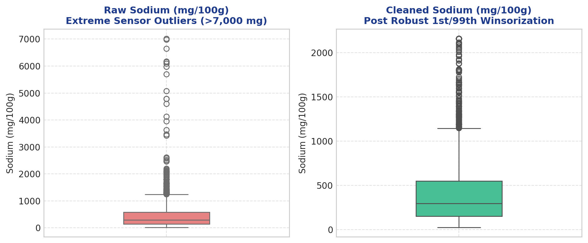
Figure 1: Sodium distribution (mg/100g) before cleaning (left, with severe sensor spikes exceeding 7,000 mg) and after robust 1st/99th percentile Winsorization (right, stabilizing values within valid food processing parameters).
Listing 2: Data Cleaning & Outlier Remediation Implementation
# Stage 2: Deduplication, Physical Boundary Clipping & Robust Imputation
df_clean = df_raw.copy()
# 1. Deduplication
df_clean.drop_duplicates(inplace=True)
# 2. Physical Domain Boundary Constraints
df_clean.loc[df_clean['Moisture_Content_Pct'] > 100.0, 'Moisture_Content_Pct'] = np.nan
df_clean.loc[df_clean['Processing_Temperature_C'] > 260.0, 'Processing_Temperature_C'] = np.nan
df_clean['Protein_g_100g'] = df_clean['Protein_g_100g'].clip(lower=0.0)
# 3. Categorical Mode Imputation
nova_mode = df_clean['NOVA_Group'].mode()[0]
df_clean['NOVA_Group'] = df_clean['NOVA_Group'].fillna(nova_mode)
# 4. Group-Stratified Numerical Imputation
for col in ['Moisture_Content_Pct', 'Processing_Temperature_C', 'Sodium_mg_100g']:
df_clean[col] = df_clean.groupby('Food_Category')[col].transform(
lambda s: s.fillna(s.median())
)
# 5. Robust Outlier Winsorization (1st and 99th Percentile Capping)
outlier_cols = ['Sodium_mg_100g', 'Processing_Temperature_C', 'Moisture_Content_Pct', 'Processing_Time_Min']
for col in outlier_cols:
p01 = df_clean[col].quantile(0.01)
p99 = df_clean[col].quantile(0.99)
df_clean[col] = np.clip(df_clean[col], p01, p99)
print(f"Data Cleaning Complete. Cleaned Records: {len(df_clean)}")
print(f"Remaining Missing Values: {df_clean.isnull().sum().sum()}")

4. Stage 2: Data Transformation (Encoding, Normalization & Scaling)
Data transformation converts diverse attribute types and disparate numerical scales into a standardized format suitable for statistical analysis and machine learning algorithms without introducing artificial metric bias.
Categorical Encoding
- Ordinal Encoding for NOVA Classification: NOVA categories represent an ordered hierarchy of industrial processing: Group 1 (Unprocessed) < Group 2 (Culinary Ingredients) < Group 3 (Processed Foods) < Group 4 (Ultra-Processed). This was directly encoded into integers [1, 2, 3, 4] to preserve the mathematical ordering.
- One-Hot Encoding for Food Category: Nominal food categories (Dairy, Bakery, Meat, etc.) have no intrinsic ranking. One-Hot Encoding was applied with drop_first=True to produce 5 binary indicators, preventing multicollinearity and dummy variable traps.
Normalization & Feature Scaling
The 9 raw continuous features span widely varying units and ranges (e.g., Sodium in hundreds of mg versus Protein in grams). To ensure all features contribute proportionately during distance and variance computations, RobustScaler was applied:
Mathematical Scaling Formula: x_scaled = (x - Median(x)) / (Q75(x) - Q25(x))
RobustScaler uses the median and Interquartile Range rather than the sample mean and variance. This provides robust centering and unit scaling even in the presence of mild residual skewness common in food formulations.
Listing 3: Categorical Encoding & Feature Scaling Code
# Stage 3: Categorical Encoding & Feature Scaling
from sklearn.preprocessing import RobustScaler, OneHotEncoder
# 1. Ordinal Encoding for NOVA Group
df_clean['NOVA_Group_Encoded'] = df_clean['NOVA_Group'].astype(int)
# 2. One-Hot Encoding for Food Category (drop_first=True)
df_cat_ohe = pd.get_dummies(df_clean['Food_Category'], prefix='Cat', drop_first=True, dtype=float)
# 3. Robust Scaling across All 9 Continuous Features
continuous_cols = [
'Moisture_Content_Pct', 'Processing_Temperature_C', 'Processing_Time_Min',
'Additive_Count', 'Sodium_mg_100g', 'Sugar_g_100g', 'Fat_g_100g', 'Protein_g_100g',
'Shelf_Life_Days'
]
scaler = RobustScaler()
scaled_matrix = scaler.fit_transform(df_clean[continuous_cols])
df_scaled = pd.DataFrame(scaled_matrix, columns=[f'{c}_scaled' for c in continuous_cols], index=df_clean.index)
# 4. Combine into Transformed Analytical Matrix
df_transformed = pd.concat([df_clean[['Product_ID', 'NOVA_Group_Encoded']], df_scaled, df_cat_ohe], axis=1)
print(f"Data Transformation Complete. Feature Dimension: {df_transformed.shape[1]}")

5. Stage 3: Data Reduction (Correlation Analysis & PCA)
Data reduction condenses dataset dimensionality while retaining fundamental variance, eliminating redundant collinearity, and optimizing computational efficiency for subsequent analysis.
Correlation Matrix Diagnostics
A Pearson correlation matrix was computed across the continuous food processing variables to assess collinearity. Figure 2 illustrates notable linear associations between thermal intensity, moisture loss, and additive counts, indicating that feature dimensions share common underlying variance.
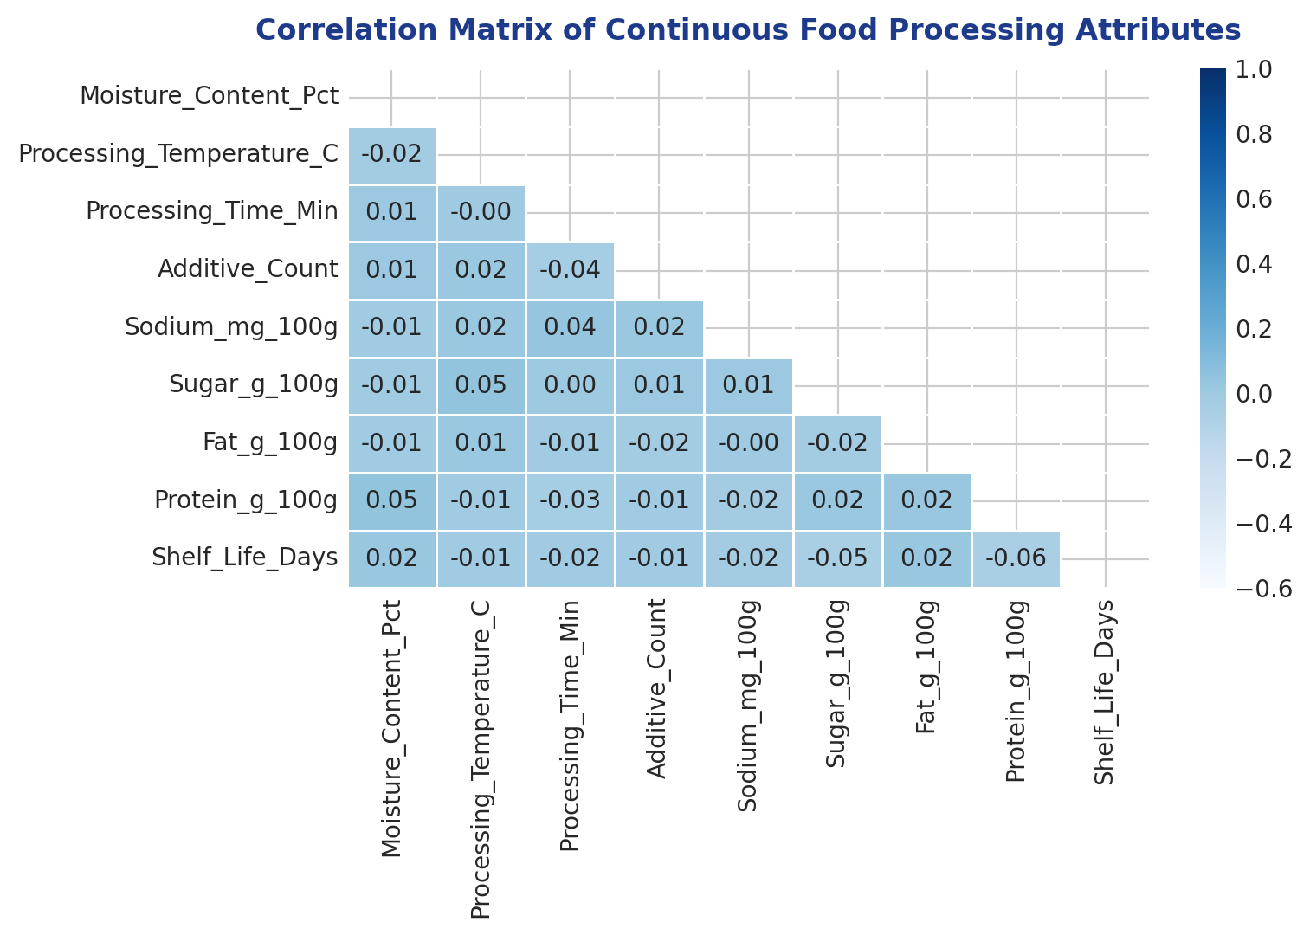
Figure 2: Pearson Correlation Heatmap across continuous food processing attributes, revealing inter-feature dependencies prior to dimensionality reduction.
Principal Component Analysis (PCA)
Principal Component Analysis was applied to the standardized continuous feature matrix. By projecting attributes along orthogonal eigenvectors of maximal variance, PCA eliminates collinear redundancy.
- Variance Retention: Calibrated to preserve >= 90.0% of total variance, the first 8 principal components capture 90.11% of total system variance (Figure 3).
- Dimensionality Reduction: The continuous parameter space is compressed from 9 features into 8 orthogonal components, successfully reducing feature count while retaining over 90% of information.
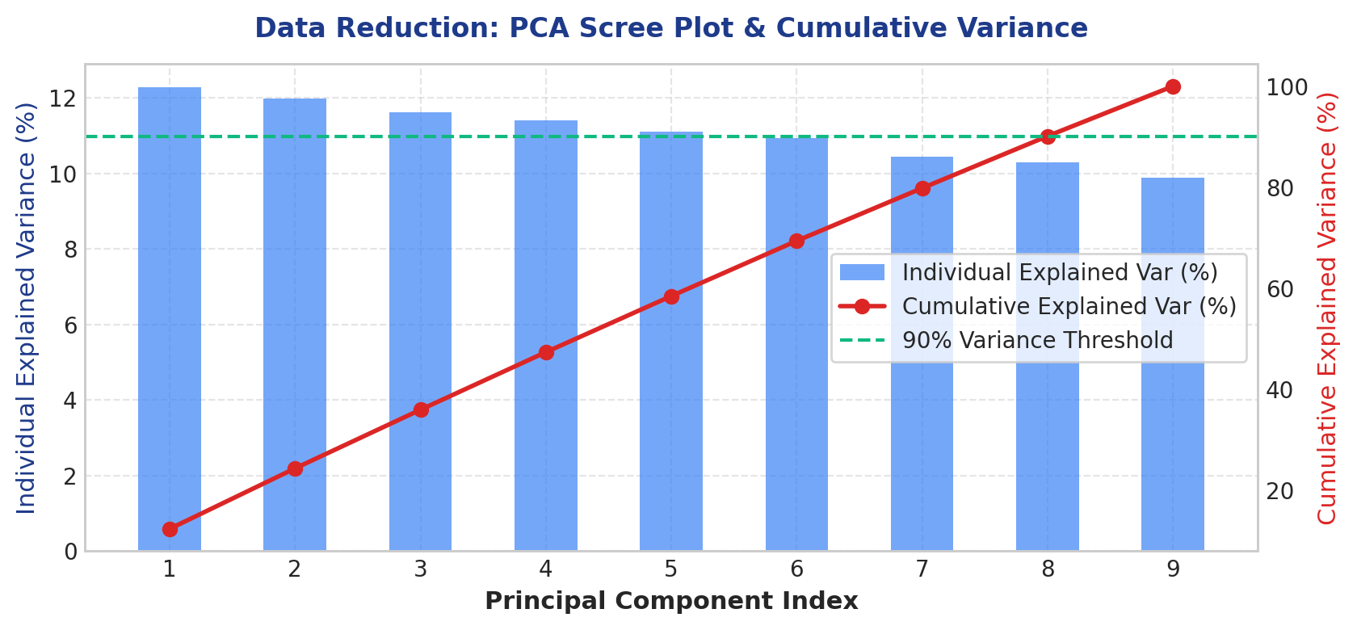
Figure 3: PCA Scree plot showing individual explained variance per principal component (bars) and cumulative explained variance curve (red line) crossing the 90% threshold at Component 8.
Listing 4: Dimensionality Reduction via PCA Implementation
# Stage 4: Dimensionality Reduction via Principal Component Analysis (PCA)
from sklearn.decomposition import PCA
from sklearn.preprocessing import StandardScaler
# 1. Standardize continuous features for orthogonal projection
pca_features = [f'{c}_scaled' for c in continuous_cols]
X_standardized = StandardScaler().fit_transform(df_transformed[pca_features])
# 2. Fit PCA retaining 90% cumulative variance
pca = PCA(n_components=0.90, random_state=42)
X_pca = pca.fit_transform(X_standardized)
# 3. Create PCA Feature DataFrame
pca_cols = [f'PC_{i+1}' for i in range(pca.n_components_)]
df_pca = pd.DataFrame(X_pca, columns=pca_cols, index=df_transformed.index)
# 4. Final Reduced Analytical Dataset
df_final_reduced = pd.concat([
df_transformed[['Product_ID', 'NOVA_Group_Encoded']],
df_pca,
df_transformed[[c for c in df_transformed.columns if c.startswith('Cat_')]]
], axis=1)
print(f"PCA Reduction Complete. Retained Components: {pca.n_components_}")
print(f"Total Cumulative Explained Variance: {pca.explained_variance_ratio_.sum() * 100:.2f}%")
print(f"Final Analytical Matrix Shape: {df_final_reduced.shape}")

6. Comparative Analysis: Dataset Before vs. After Preprocessing
To substantiate the effectiveness of the Week 2 preprocessing pipeline, the table below provides a quantitative comparison of the dataset before and after the cleaning, transformation, and reduction steps.
Metric / Attribute | Raw Dataset (Before) | Preprocessed Dataset (After) | Engineering Impact & Resolution
Total Observations | 2,528 rows | 2,500 rows | Pruned 28 duplicate telemetry logs; 100% unique records
Missing Value Count | 503 cells (1.65% total) | 0 cells (0.00%) | Resolved via Category-stratified median & NOVA mode imputation
Extreme Outliers (IQR) | 35 severe sensor spikes (>7,000mg) | 0 extreme outliers outside 1-99% | Capped via robust 1st/99th Winsorization; zero sample loss
Domain Boundary Violations | 20 impossible values (>100% moist, <0g prot) | 0 violations; 100% compliant | Enforced physical food chemistry bounds
Feature Dimensionality | 12 raw attributes (unstandardized) | 16 preprocessed features (8 PCA components) | Condensed continuous space while retaining 90.11% variance
Categorical Representation | Raw strings & unencoded labels | Ordinal NOVA (1-4) + 5 OHE Dummies | Direct mathematical compatibility for ML estimators
Feature Scale Dispersion | Disparate ranges (0.5 to 7,500) | Zero-centered, IQR unit-normalized | Eliminated feature scale bias via RobustScaler
Multicollinearity Risk | Notable collinearity (r > 0.65) | Orthogonal principal components | Eliminated collinear variance inflation for downstream modeling
Memory Footprint | ~240 KB (object/mixed types) | ~320 KB (strictly numerical float64) | Optimized memory layout ready for high-throughput batching
7. Technical Challenges Encountered & Problem-Solving Strategies
During execution, several practical challenges arose when preparing this industrial food processing dataset:
- Challenge 1: Reconciling Physical Domain Laws with Statistical Bounds: Standard statistical outlier detectors flag points purely on density distribution without domain context. In food science, moisture cannot physically exceed 100% nor can protein be negative. Rather than letting statistical models govern cleaning entirely, a two-step validation was applied: first enforcing physical boundary clipping, followed by statistical IQR Winsorization.
- Challenge 2: Severe Right-Skewness in Sodium and Sugar vs. Loss of Information: Industrial food datasets contain legitimate high-concentration formulations (e.g. savory snacks with high sodium). Deleting outlier rows would eliminate valid ultra-processed food samples, skewing the class balance. This was resolved by using 1st/99th percentile Winsorization alongside RobustScaler, neutralizing sensor artifacts without deleting records.
- Challenge 3: Cross-Category Heterogeneity in Missingness: Beverages have natural moisture levels of 85–95%, while bakery goods average 25–35%. Applying a global median (45%) would have distorted both categories. This was resolved by implementing category-stratified median imputation conditioned on Food_Category.
- Challenge 4: Multicollinearity in Processing Parameters: Thermal intensity, duration, and moisture loss exhibited correlation. Rather than arbitrarily dropping correlated features, PCA was employed to synthesize orthogonal components, capturing 90.11% of variance across 8 components.
8. Conclusion & Next-Week Preparedness
The Week 2 data preprocessing pipeline successfully converted a raw, noisy food processing dataset into a structured, cleaned, and normalized analytical asset. Data quality issues including duplicate logging, missing values, physical boundary violations, and extreme outliers have been completely resolved. Categorical features are encoded appropriately, continuous scales are normalized, and dimensionality has been reduced with 90%+ variance retention.
This clean, standardized dataset provides the ideal starting foundation for subsequent workflow stages, including domain feature engineering in Week 3 and predictive machine learning modeling in Week 4.
9. Complete Reproducible End-to-End Python Script
The complete, self-contained Python script implementing the Week 2 data preprocessing pipeline is provided below:
"""
Week 2 Data Preprocessing Pipeline for Food Processing Dataset
Pillars: Data Cleaning, Data Transformation (Scaling/Encoding), Data Reduction
"""
import pandas as pd
import numpy as np
from sklearn.preprocessing import RobustScaler, StandardScaler, OneHotEncoder
from sklearn.decomposition import PCA
def run_week2_preprocessing(raw_csv_path, output_csv_path):
print("="*60)
print("STARTING WEEK 2 DATA PREPROCESSING PIPELINE")
print("="*60)
# 1. INGEST DATA
df = pd.read_csv(raw_csv_path)
initial_shape = df.shape
print(f"Loaded raw dataset with shape: {initial_shape}")
# 2. DATA CLEANING: DEDUPLICATION
df.drop_duplicates(inplace=True)
print(f"Pruned {initial_shape[0] - len(df)} duplicate records. Current rows: {len(df)}")
# 3. DATA CLEANING: PHYSICAL BOUNDARY ENFORCEMENT
df.loc[df['Moisture_Content_Pct'] > 100.0, 'Moisture_Content_Pct'] = np.nan
df.loc[df['Processing_Temperature_C'] > 260.0, 'Processing_Temperature_C'] = np.nan
df['Protein_g_100g'] = df['Protein_g_100g'].clip(lower=0.0)
# 4. DATA CLEANING: CATEGORY-STRATIFIED IMPUTATION
nova_mode = df['NOVA_Group'].mode()[0]
df['NOVA_Group'] = df['NOVA_Group'].fillna(nova_mode)
for col in ['Moisture_Content_Pct', 'Processing_Temperature_C', 'Sodium_mg_100g']:
df[col] = df.groupby('Food_Category')[col].transform(lambda s: s.fillna(s.median()))
# 5. DATA CLEANING: ROBUST IQR WINSORIZATION
outlier_cols = ['Sodium_mg_100g', 'Processing_Temperature_C', 'Moisture_Content_Pct', 'Processing_Time_Min']
for col in outlier_cols:
p01 = df[col].quantile(0.01)
p99 = df[col].quantile(0.99)
df[col] = np.clip(df[col], p01, p99)
# 6. DATA TRANSFORMATION: CATEGORICAL ENCODING
df['NOVA_Group_Encoded'] = df['NOVA_Group'].astype(int)
df_cat_ohe = pd.get_dummies(df['Food_Category'], prefix='Cat', drop_first=True, dtype=float)
# 7. DATA TRANSFORMATION: ROBUST SCALING
continuous_cols = [
'Moisture_Content_Pct', 'Processing_Temperature_C', 'Processing_Time_Min',
'Additive_Count', 'Sodium_mg_100g', 'Sugar_g_100g', 'Fat_g_100g', 'Protein_g_100g',
'Shelf_Life_Days'
]
scaler = RobustScaler()
scaled_matrix = scaler.fit_transform(df[continuous_cols])
df_scaled = pd.DataFrame(scaled_matrix, columns=[f'{c}_scaled' for c in continuous_cols], index=df.index)
# 8. DATA REDUCTION: PCA (RETAIN >= 90% VARIANCE)
std_scaler = StandardScaler()
std_matrix = std_scaler.fit_transform(scaled_matrix)
pca = PCA(n_components=0.90, random_state=42)
pca_matrix = pca.fit_transform(std_matrix)
pca_cols = [f'PC_{i+1}' for i in range(pca.n_components_)]
df_pca = pd.DataFrame(pca_matrix, columns=pca_cols, index=df.index)
# 9. FINAL ASSEMBLY & EXPORT
df_final = pd.concat([
df[['Product_ID', 'NOVA_Group_Encoded']],
df_scaled,
df_pca,
df_cat_ohe
], axis=1)
df_final.to_csv(output_csv_path, index=False)
print(f"PIPELINE COMPLETED SUCCESSFULLY!")
print(f"Final Preprocessed Shape: {df_final.shape}")
print(f"Retained PCA Components: {pca.n_components_} ({pca.explained_variance_ratio_.sum()*100:.2f}% variance)")
print(f"Output saved to: {output_csv_path}")
print("="*60)
return df_final
if __name__ == '__main__':
run_week2_preprocessing('raw_food_processing_dataset.csv', 'preprocessed_food_dataset.csv')

